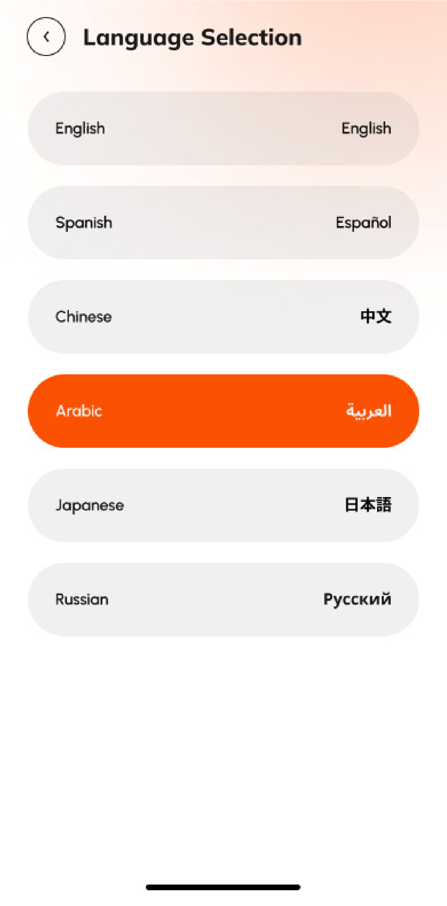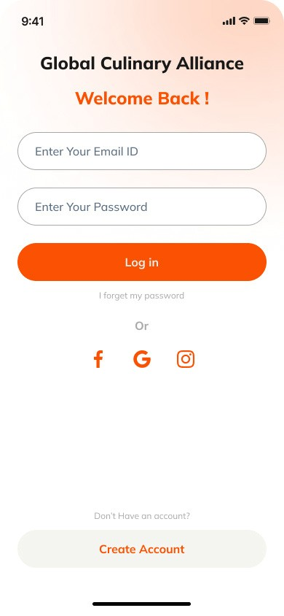
Remove the Word NEWS
and adapt the design to
look similar to the app
Change this to GCA
SINGAPORE
Use API for
automatic
translation to all
languages.
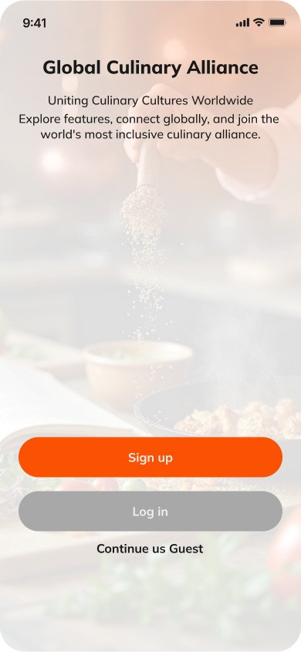
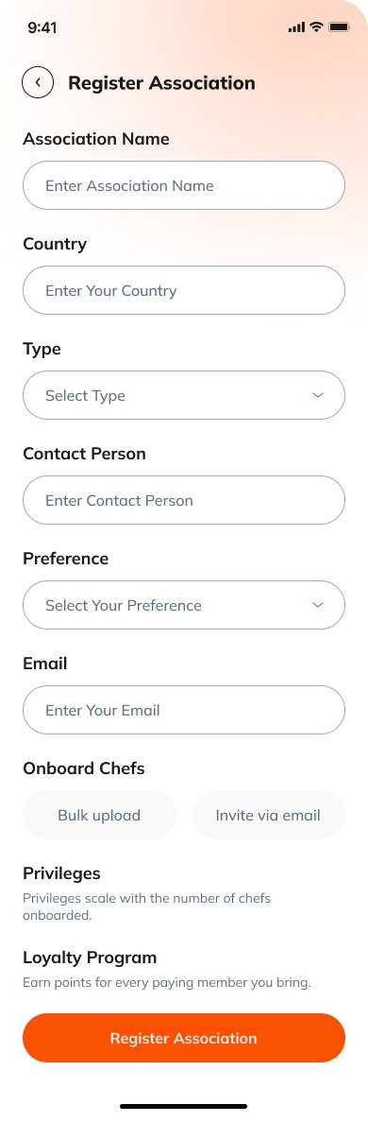
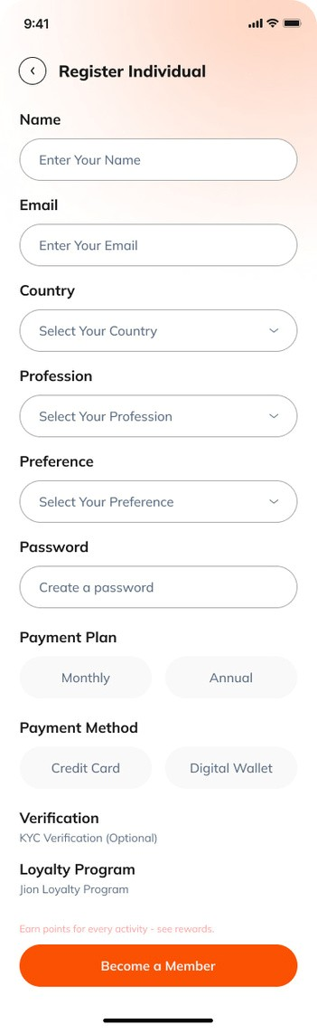
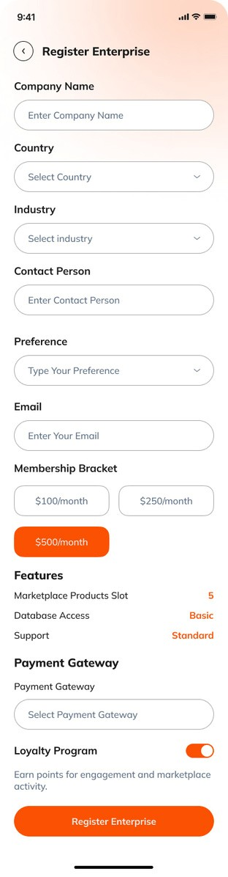
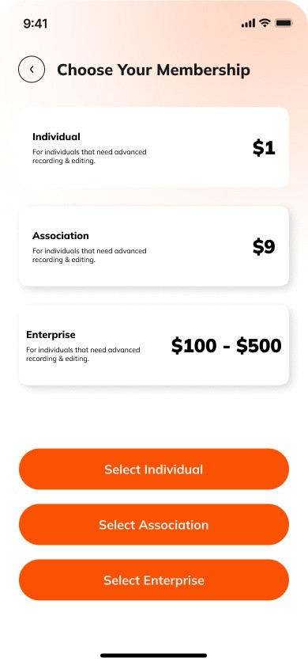

We need to
add the
questionnaire
for User
Preference
with all the
Registration
Forms.
We need to add a
“CALL TO ACTION”
button here...
“RECOMMEND GCA YOUR
COLLEGUE AND JOIN THE
REVOLUTION”
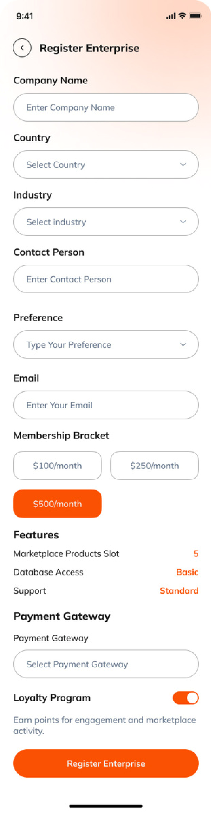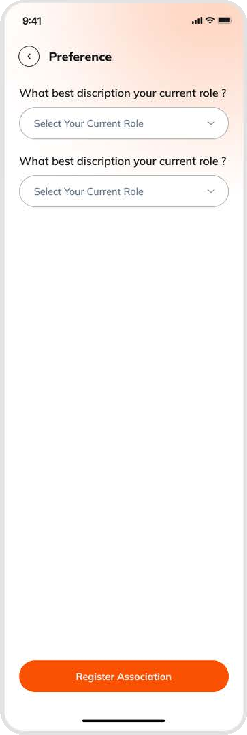
PREFERENCE
FORM HAS
BEEN
PROVIDED
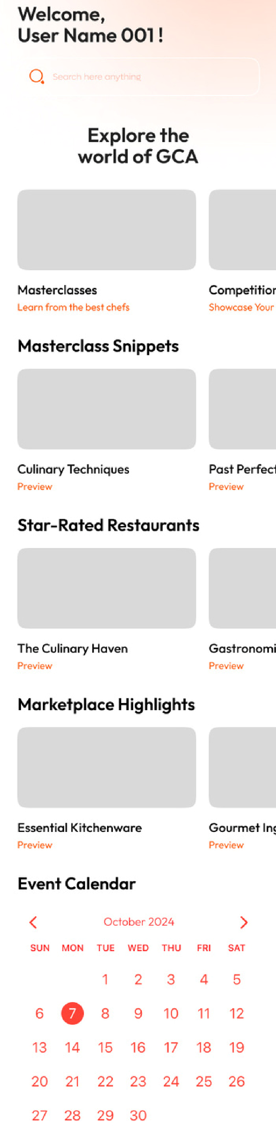
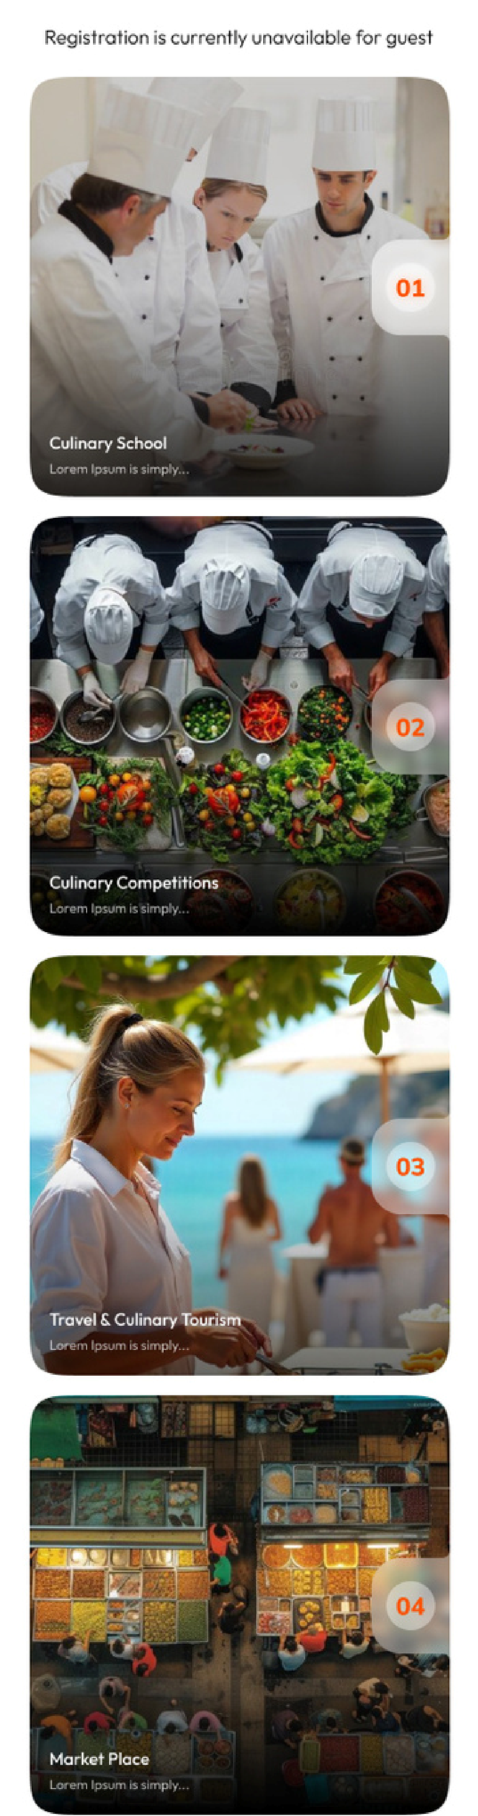
From the landing page
the user can go to any
other page of his or her
choice... masterclass,
culinary education,
competitions etc
GO TO COMPETITIONS
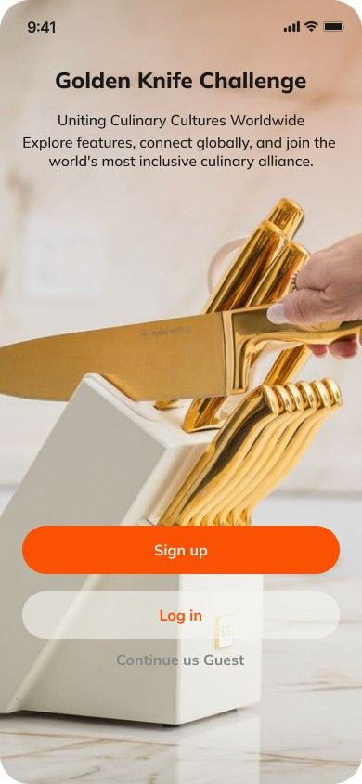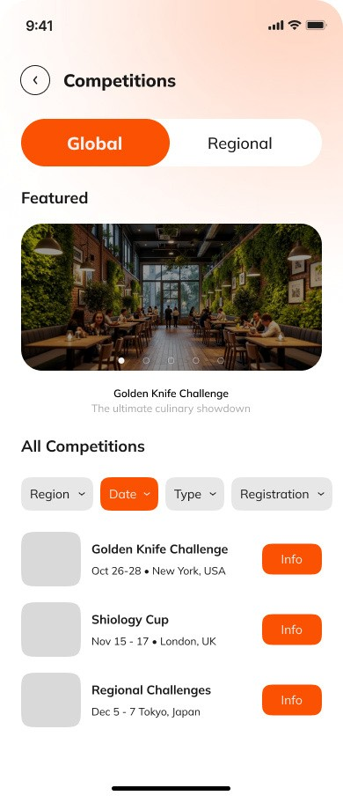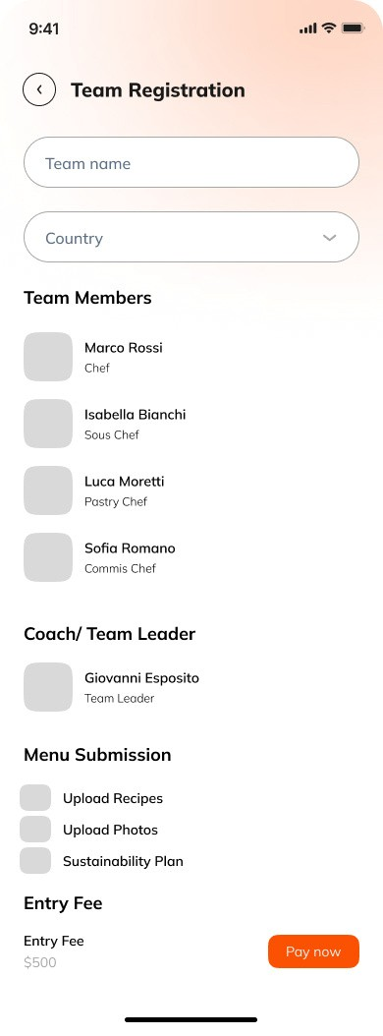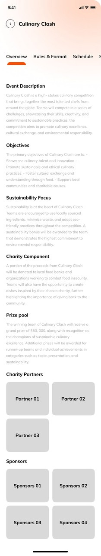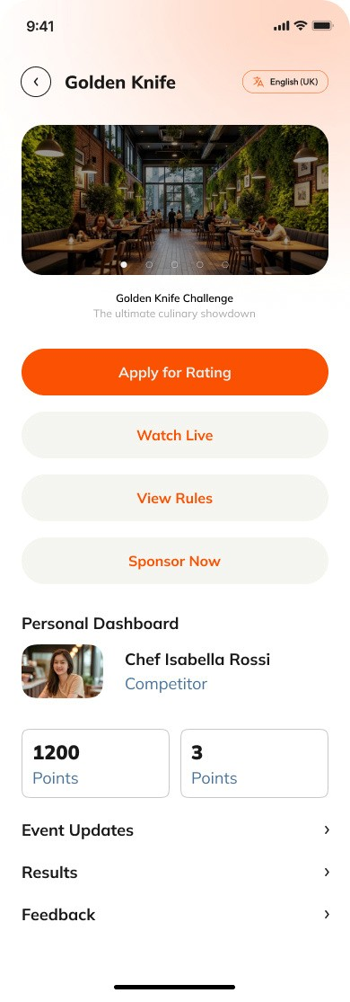
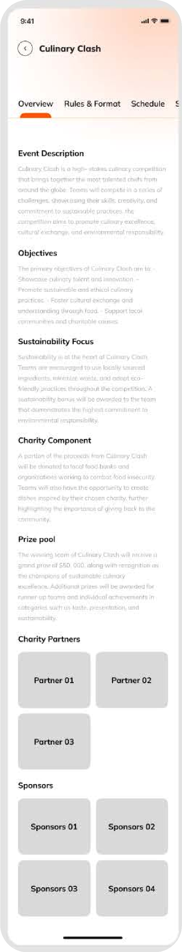
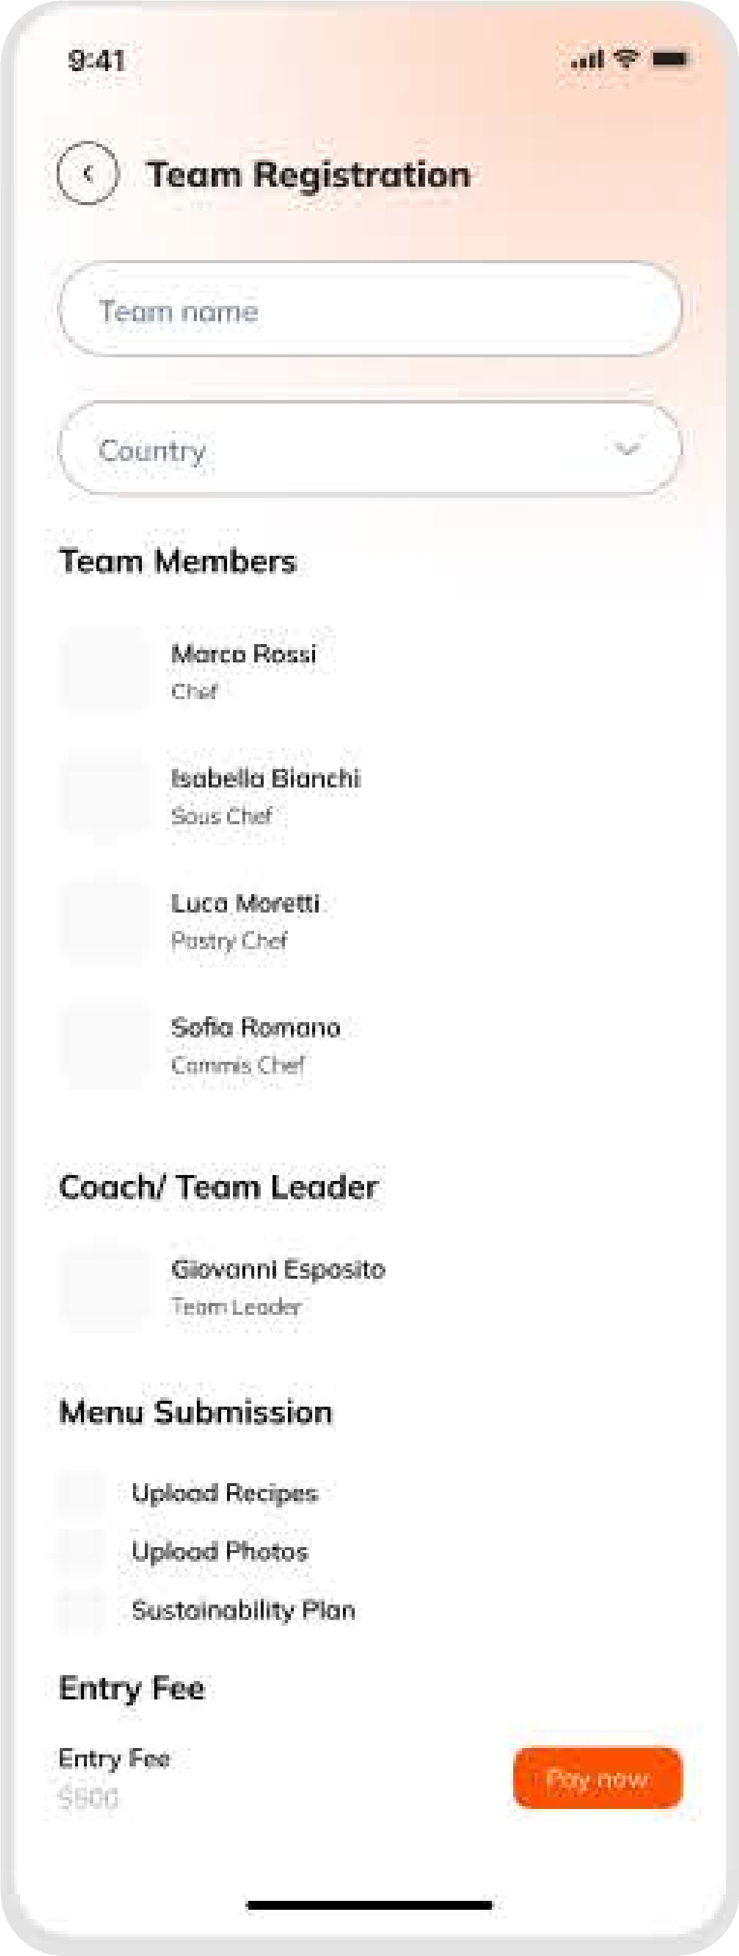
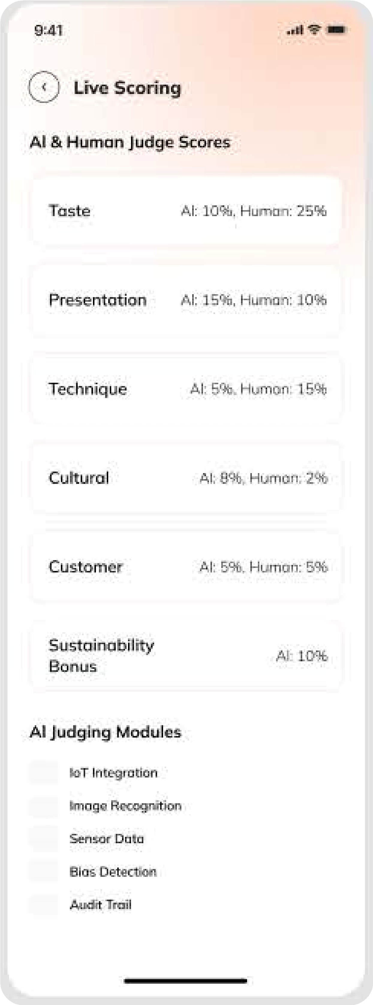
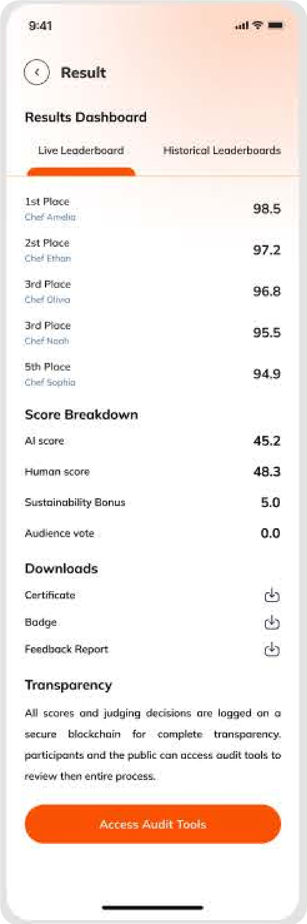
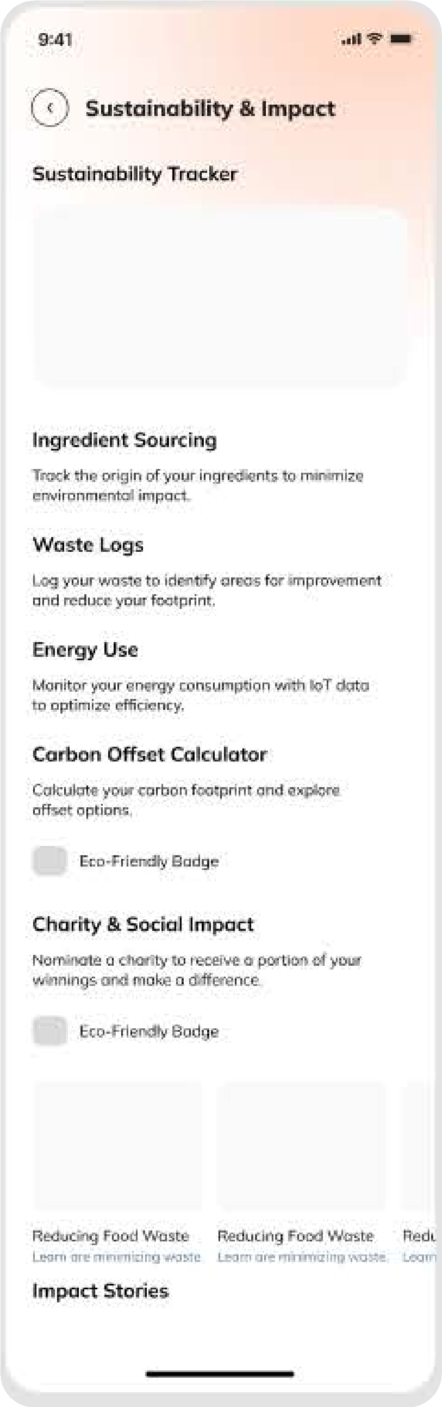
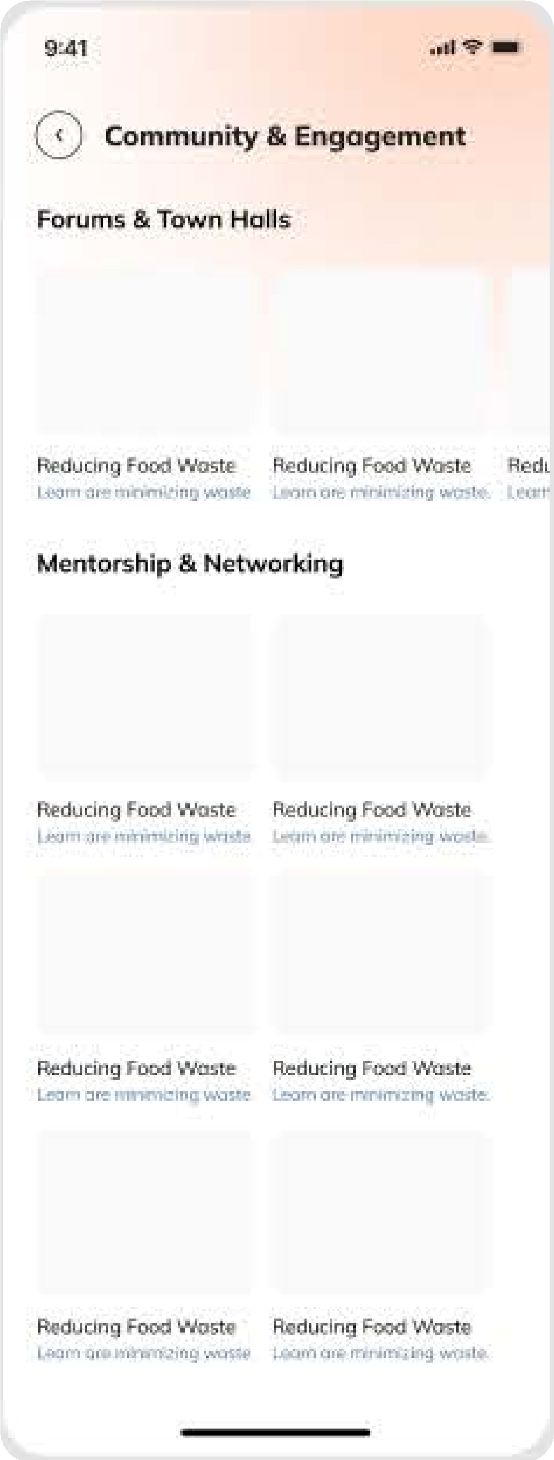
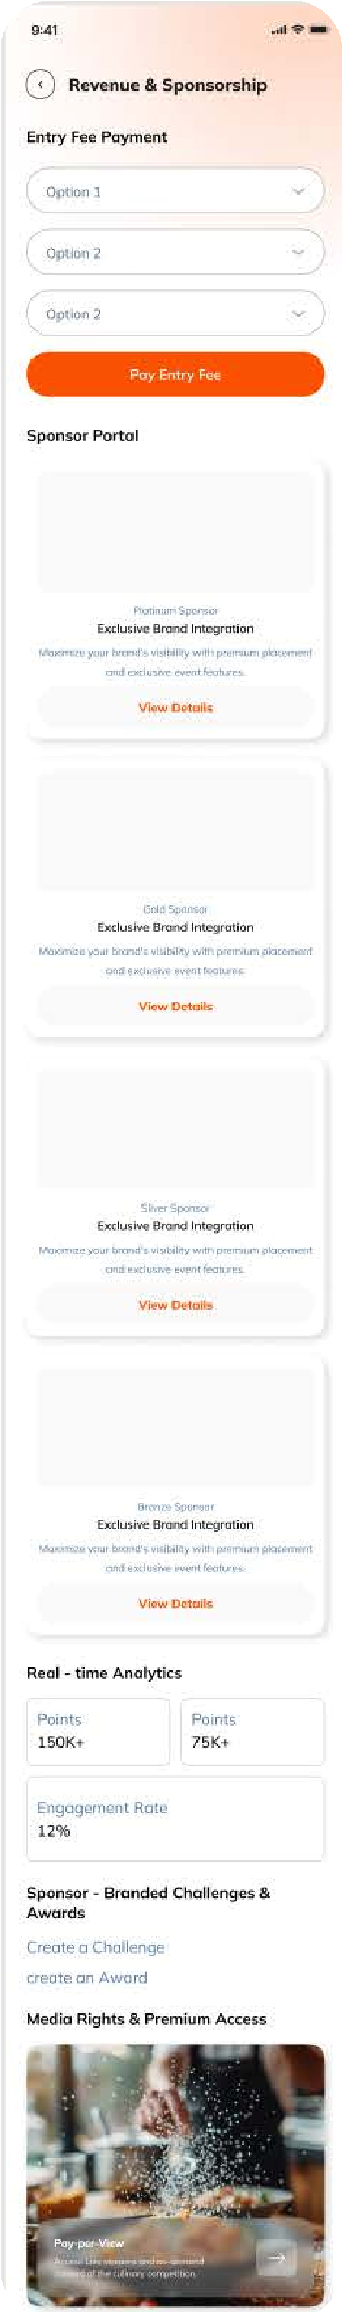

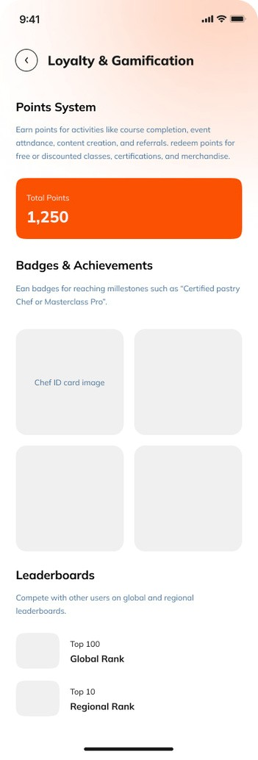
1. Professional Role & Background
•What best describes your current role? •(Chef, Pastry Chef, Student, Educator, Supplier, Home Cook, Food Writer, Restaurant Owner, Hotelier, Other) •What is your current place of work or study? Open text field) •How many years of experience do you have in the culinary field?(0-2, 3-5, 6-10, 10+)

2. Culinary Interests & Specializations •Which areas of culinary arts are you most interested in? (Multiple select: World cuisines, Pastry/Bakery, Molecular gastronomy, Food technology, Sustainability, Plant-based, Heritage cuisine, Culinary competitions, Food safety, Hospitality management, Other) •What cuisines or techniques do you want to explore or master? (Multiple select or open text)

3. Professional Goals & Aspirations
•What are your main goals as a GCA member? (Select all that apply) oAdvance my culinary skills through education and masterclasses oGain international experience (internships, exchanges) oCompete in global culinary competitions oAchieve professional certifications oBuild a global culinary network oFind new job or business opportunities oMentor or be mentored oPromote sustainability in gastronomy oAccess mental health and wellness resources oContribute to culinary research and publications oOther (please specify)

4. Preferred Learning & Engagement Formats
•How do you prefer to engage with the GCA community? (Live masterclasses, On-demand courses, In-person events, Online forums, Group projects, One-on-one mentorship) •What topics or skills would you like to see more content on? (Open text or multiple select)

5. Geographic & Cultural Preferences •Which regions or countries are you most interested in for culinary exchange, travel, or events? (Multiple select) •Are you interested in participating in cultural or culinary heritage preservation projects? (Yes/No)

6. Sustainability & Social Impact •Are you interested in sustainability initiatives (e.g., zero-waste, local sourcing, eco certification)? (Yes/No) •Would you like to join GCA’s food security or social impact programs? (Yes/No)

7. Community & Networking •Are you interested in joining peer groups, networking clubs, or alumni communities? (Yes/No) •Would you like to be matched with a mentor or mentee? (Mentor, Mentee, Both, Not now)

8. Communication & Notification Preferences •How would you like to receive updates and recommendations? (Email, App notifications, SMS, Weekly digest, Only important updates)

9. Consent & Privacy •Do you consent to GCA using your responses to personalise your app experience, in line with our privacy policy?(Yes/No)

